**EXERCISE NO.5**

**DATE:14/10/2020**

**AIM:**

To write a python program to print the missing characters to make the string pangram.

**PROGRAM:**

def pangram(string):

alphabets="abcdefghijklmnopqrstuvwxyz"

for letter in alphabets:

if letter not in string.lower():

print(letter,end="")

string=input()

pangram(string)

**LINK:**

<http://103.53.53.18/mod/vpl/forms/submissionview.php?id=235&userid=1743>

**OUTPUT:**

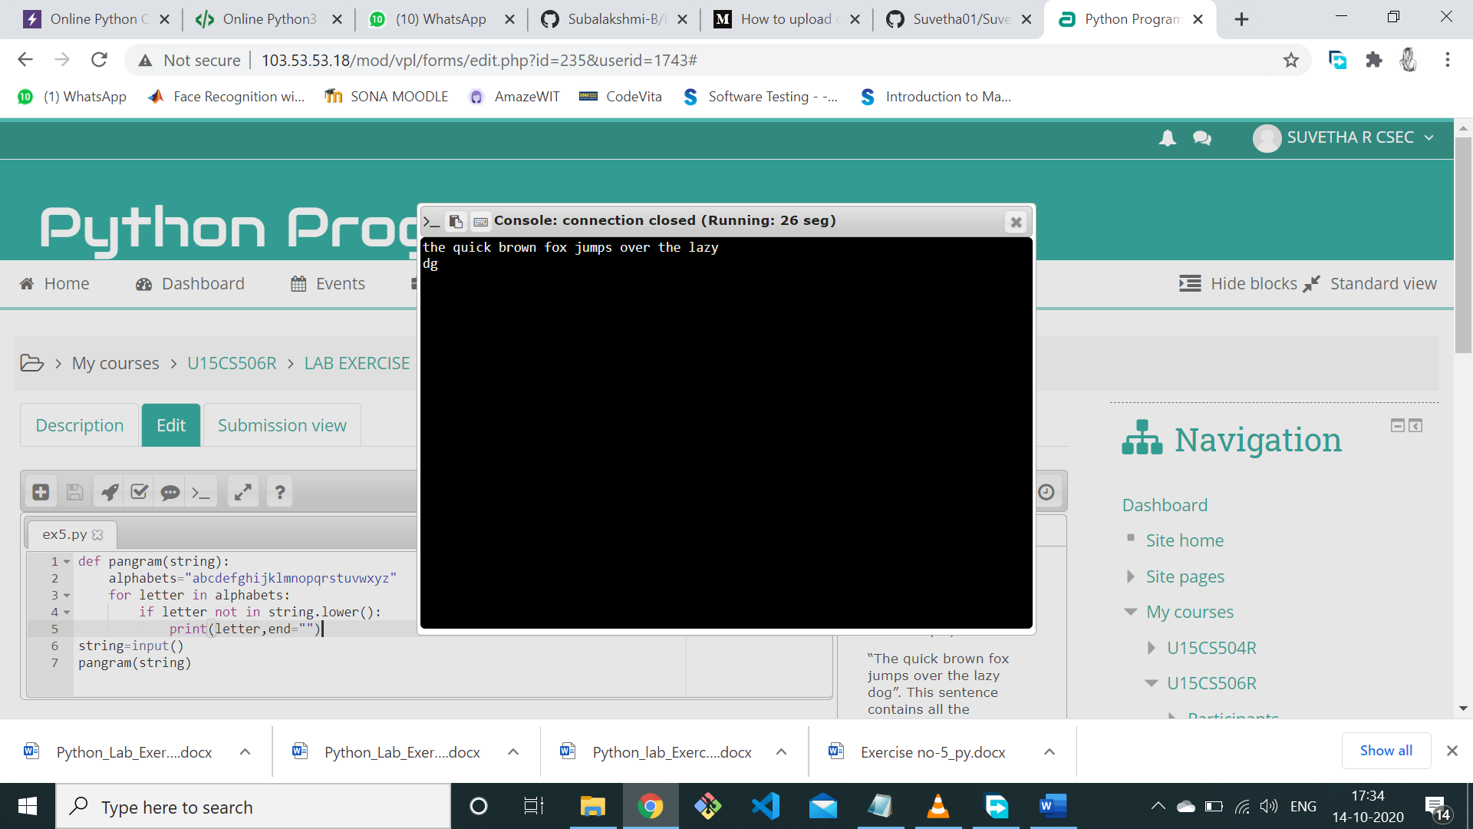

**RESULT:**

Finding the missing characters is done and the output is verified.